1D FEM CODE TO SOLVE GOVERNING EQUATION OF A BEAM SUBJECTED TO VARIOUS LOADS.

A project report submitted in the fulfillment of the requirement for the course.

AE675 INTRODUCTION TO FINITE ELEMENT METHODS



Professor

DR. P M MOHITE

Department of Aerospace Engineering

Submitted by

Suresh Ragireddy 231010079

Bala Bhanu Prakash G 231010027

First Year Postgraduates

Department of Aerospace Engineering, IIT Kanpur

**Write a one-dimensional finite element code using Hermite cubic shape functions with the following details for the beam bending problem**.

1. Uniform cross section: $1 cmX1 cm$
2. Length of the beam: $10 cm$
$E=200GPa$

3. The code should be capable of handling the transverse loads of the type.

a. Concentrated/point load.

b. Uniformly distributed load

c. Point moments at the center of the beam length only

1. Further, it should be capable of applying the appropriate combination of boundary conditions at either of the ends as:

a. Specified transverse displacement.

b. Specified slope of the transverse displacement.

c. Shear force

d. Bending moment

**Now, take appropriate values of loads as mentioned in Point # 4 above and perform the following finite element analysis using your code for $1,4,10,50$ and 100 elements.**

1. Give continuous variation of transverse displacement and its slope.
2. Give continuous variation of shear force and bending moment.
3. Bending stress on the topmost line of beam along its entire length.

**Discuss your results and verify those using Euler Bernoulli beam theory closed form solutions.**

|  |  |
| --- | --- |
| **Euler Bernoulli beam theory closed form solutions** | **FEM Solution** |
| **Test Case -1**   * Cantilever beam of 10 cm length width $1 cm^{2}$ cross-section,fixed at one end. * End point load $P=3$ kN applied at the free end. * . Material’s Young’s modulus $E=200$ GPa. |  |
| **Deflection** | |
|  |  |
| **Bending Moment Diagram** | |
|  |  |
| **Shear Force Diagram** | |
|  |  |
|  |  |

|  |  |
| --- | --- |
| **Euler Bernoulli beam theory closed form solutions** | **FEM Solution** |
| **Test Case -2**   * Prismatic beam with a $1{cm}^{2}$ cross-section and 10cm length, fixed at one end. * Material property: Young’s modulus($E$)of 200 GPa. * Subject to a uniform load of 2 KN/m along its entire length. |  |
| **Deflection** | |
|  |  |
| **Bending Moment Diagram** | |
|  |  |
| **Shear Force Diagram** | |
|  |  |
|  |  |

|  |  |
| --- | --- |
| **Euler Bernoulli beam theory closed form solutions** | **FEM Solution** |
| **Test Case -3**   * Fixed beam with a $1\cos^{2}$ cross-section and $10cm$ length, experiencing a uniform load $q=$ 2 KN/m. * An additional point load $P=3$ kN is applied at 20 mm from the fixed end. * The beam’s material has a Young’s modulus ($E$) of 200 GPa. |  |
| **Deflection** | |
|  |  |
| **Bending Moment Diagram** | |
| z |  |
| **Shear Force Diagram** | |
|  |  |
|  |  |

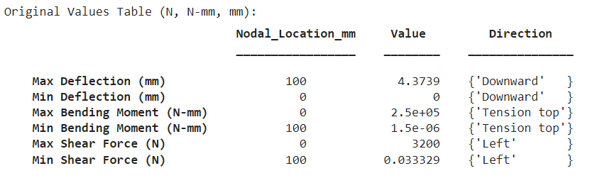

|  |  |
| --- | --- |
| **Euler Bernoulli beam theory closed form solutions** | **FEM Solution** |
| **Test Case -4**   * Simply supported beam of length 10 cm with a cross-section of $1{ cm}^{2}$* Point load $P=3$ KN applied at the midpoint of the beam. * Material property: Elastic modulus $E=200$ GPa. |  |
| **Deflection** | |
|  |  |
| **Bending Moment Diagram** | |
|  |  |
| **Shear Force Diagram** | |
|  |  |
|  |  |

|  |  |
| --- | --- |
| **Euler Bernoulli beam theory closed form solutions** | **FEM Solution** |
| **Test Case -5**   * Simply supported beam with a $1{cm}^{2}$ cross-section, 10cm in length, under a uniform distributed load (UDL) of $q=2$ kN/m. * A point load $P=3$ kN is applied 30 mm from the right support. * The beam material’s Young’s modulus is $E=200$ GPa. |  |
| **Deflection** | |
|  |  |
| **Bending Moment Diagram** | |
|  |  |
| **Shear Force Diagram** | |
|  |  |
|  |  |

|  |  |
| --- | --- |
| **Euler Bernoulli beam theory closed form solutions** | **FEM Solution** |
| **Test Case -6**   * Cantilever beam of $10{ cm length and 1 cm}^{2}$ cross-section, fixed at one end. * Point load $P=3$ kN applied 30 mm from the free end . * Beam material has an elastic modulus $E=200$ GPa. |  |
| **Deflection** | |
|  |  |
| **Bending Moment Diagram** | |
|  |  |
| **Shear Force Diagram** | |
|  |  |
|  |  |

|  |  |
| --- | --- |
| **Euler Bernoulli beam theory closed form solutions** | **FEM Solution** |
| **Test Case -7**   * Cantilever beam with a $1{cm}^{2}$ cross-section and 10cm length, experiencing a 2kN/m uniform distributed load. * A 3 KN point load is applied at a distance of 70 mm from the fixed support. * Material property: Young’s modulus $E$ of 200 GPa |  |
| **Deflection** | |
|  |  |
| **Bending Moment Diagram** | |
|  |  |
| **Shear Force Diagram** | |
|  |  |
|  |  |

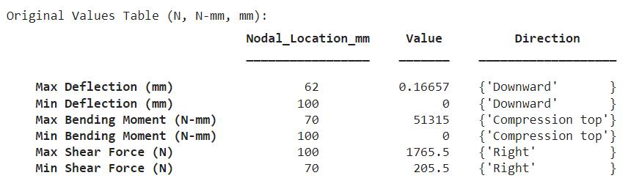

|  |  |
| --- | --- |
| **Euler Bernoulli beam theory closed form solutions** | **FEM Solution** |
| **Test Case -8**   * Simply supported beam with a $1{cm}^{2}$ cross-section and 10cm length, subjected to a 2 kN/m uniform distributed load. * A point load of 3 kN is applied 20 mm from the right support. * The beam material’s Young’s modulus is $E=200$ GPa. |  |
| **Deflection** | |
|  |  |
| **Bending Moment Diagram** | |
|  |  |
| **Shear Force Diagram** | |
|  |  |
|  |  |

|  |  |
| --- | --- |
| **Euler Bernoulli beam theory closed form solutions** | **FEM Solution** |
| **Test Case -9**   * Simply supported beam of 10 cm length and $1{ cm}^{2}$ cross-section · * Uniformly distributed load $q=2$ kN/m across the entire span. * Beam material has an elastic modulus $E=200$ GPa. |  |
| **Deflection** | |
|  |  |
| **Bending Moment Diagram** | |
|  |  |
| **Shear Force Diagram** | |
|  |  |
|  |  |

